**Spring MVC Overview**

> Framework for building web applications in Java

> Based on **Model – View – Controller** design pattern

> Leverages features of the Core Spring Framework (IoC, DI)

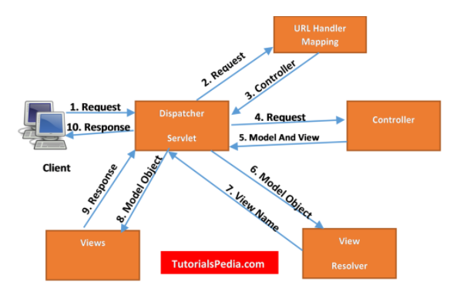

**Explanation of Spring MVC Request Flow**

1. Client requests for a page by specifying the Web URL for the page. E.g., <https://github.com>

2. Client request is intercepted by the Dispatcher Servlet (part of the Spring framework) also known as Front Controller. **Dispatcher Servlet** is a servlet specified in **Web.XML** file (for XML based configuration).

3. Dispatcher Servlet uses **URL Mapping Handler** to find out the relevant controller class to which request should be passed for subsequent processing. For e.g. If you have a Controller defined for all requests by specifying “/” in the URL, all requests will be entertained by that **controller**.

4. Once Dispatcher Servlet has identified the controller to be considered, it passes the client request to the controller.

5. The controller class is the main class controlling the business logic flow once request has been dispatched it by dispatcher servlet. This class will implement the methods for different type of http requests (e.g., GET, POST) & all logic to call Service layer methods will reside in this controller class.

The controller class will also be responsible for returning the **ModelAndView** object back to the dispatcher servlet after getting all business logic executed & any data returned from DAO layer. **ModelAndView** object returned by the controller back to the controller specified both view & model objects.

Controller class is annotated by **@Controller** annotation.

8. After receiving **ModelAndView** object from the controller, Dispatcher Servlet now sends model object to view resolver to get the name of the view which needs to be rendered.

9. Once the view to be rendered has been identified, Dispatcher Servlet passes model object to the view. Model object contains the data which needs to be displayed in the view. View will be rendered with the model data. Views can be designed in any front – end technology.

10. This view is returned to the client & client can see the view & associated data on his browser.

Views can be a HTML page or JSP page or Thymleaf or Velocity or FreeMarker

**Spring MVC Benefits**

* The Spring way of building web app UIs in Java
* Leverage a set of reusable UI components
* Help manage application state for web requests
* Process form data: validation, conversion etc.
* Flexible configuration for the view layer

**Spring MVC Documentation**: - <https://docs.spring.io/spring-framework/docs/current/reference/html/web.html>

**Components of a Spring MVC Application**

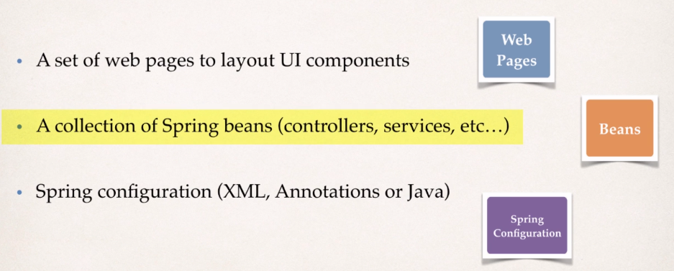

**a) Controller**

> Code created by developer

> Contains your business logic

* Handle the request
* Store/ retrieve data (db, web service…)
* Place data in model

> Send to appropriate view template

**b) Model**

> Model: contains your data

> Store/ retrieve data via backend systems

* Database, web service, etc…
* Use a Spring bean if you like

> Place your data in the model

* Data can be any Java object/ collection

**c) View Template**

> Spring MVC is flexible

* Supports many view templates

> Most common is JSP (Java Server Pages) + JSTL (JSP Standard Tag Library)

> Developer creates a page

* Displays data

> Other view templates supported

* Thymeleaf, Groovy
* Velocity, Freemarker etc…